SANKOFA Master Plan for America Kidnapped Africans
A Strategic Blueprint for Cultural, Economic, Political, and Social Liberation

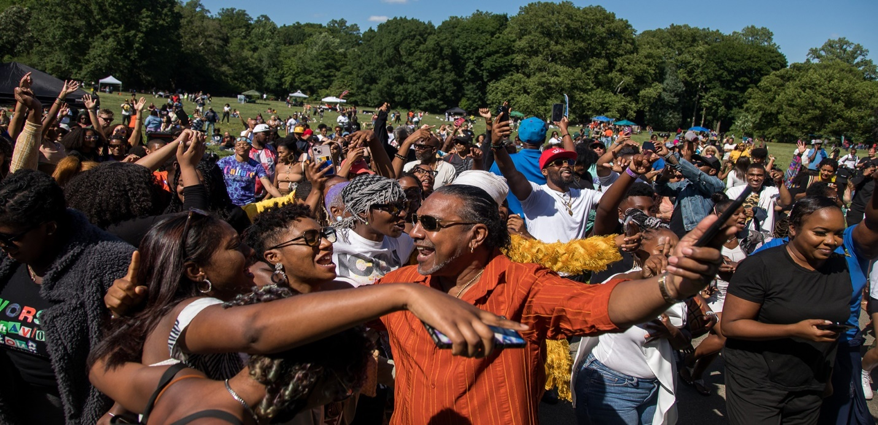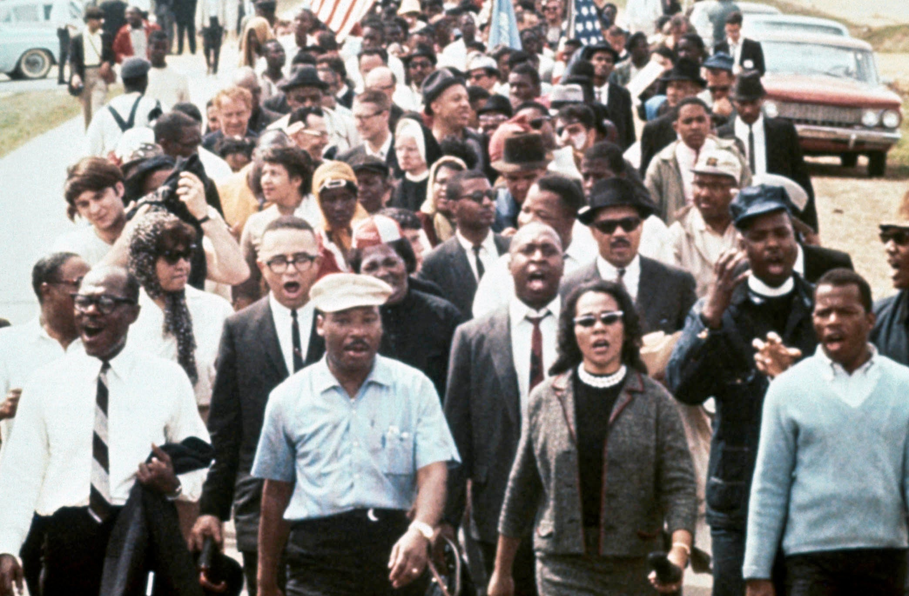Sankofa Master Plan Movement
A Strategic Blueprint for the Cultural, Economic, Political, and Spiritual Advancement of the Kidnapped African Communities of North America
SANKOFA Master Plan for America Kidnapped Africans
A Strategic Blueprint for Cultural, Economic, Political, and Social Liberation
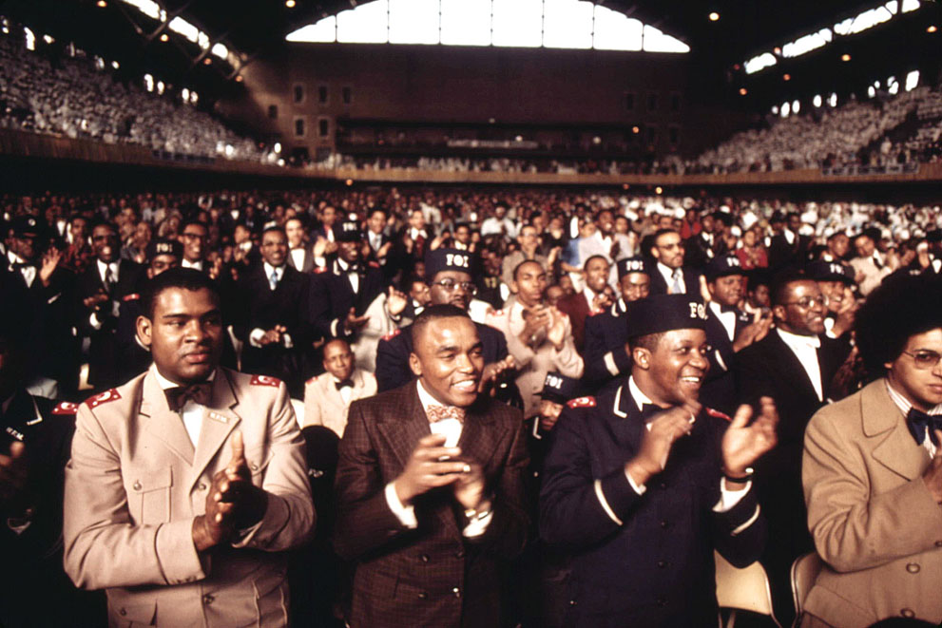 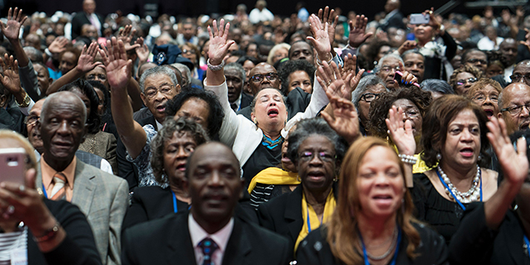SANKOFA Master Plan for America Kidnapped Africans
A Strategic Blueprint for Cultural, Economic, Political, and Social Liberation

I. Mission Statement
The Sankofa Master Plan Movement is dedicated to the reclamation, restoration, and advancement of the Kidnapped African people in the United Snakes of America, through unity, cultural pride, economic independence, political empowerment, and holistic wellness. Rooted in the spirit of Sankofa—to “go back and fetch it”—this movement seeks to reclaim what was lost through centuries of displacement and build a sustainable, self-determined future grounded in our Ancestral wisdom and collective power.

II. Core Goals
- To create a self-sustaining ecosystem through-out the Kidnapped African Communities of North America, rooted in cooperative economics and cultural integrity.
- To promote intergenerational leadership and community self-governance.
- To ensure holistic well-being—mentally, physically, and spiritually—for all people of Kidnapped African descent here in the United Snakes of America
- To establish measurable systems for accountability, data collection, and continuous improvement.
- To unify the Kidnapped African-descended communities under a single actionable movement for liberation and prosperity.

III. Departments Overview
Each Department will operate as an autonomous yet interdependent body contributing to the larger Sankofa Master Plan Movement.

Cultural Expression Department:
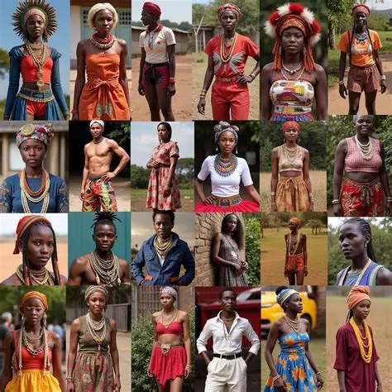
Mission Statement: To preserve, celebrate, and expand African culture as the foundation of identity, creativity, and collective empowerment.
Goals:
Promote Afrocentric artistic expression and heritage preservation.
- Promote Afrocentric artistic expression and heritage preservation.
- Support local and diaspora artists, designers, and cultural producers.
- Institutionalize African-centered cultural education.
Statement of Purpose: To ensure that culture remains the heartbeat of the Sankofa movement and the spiritual glue that binds our Kidnapped African identity.

Officers:
Chairman – Oversees overall operations and strategic direction.
Vice Chairman – Coordinates implementation and assists with planning.
Secretary – Manages documentation, reporting, and internal communications.
Economic & Business Development Department: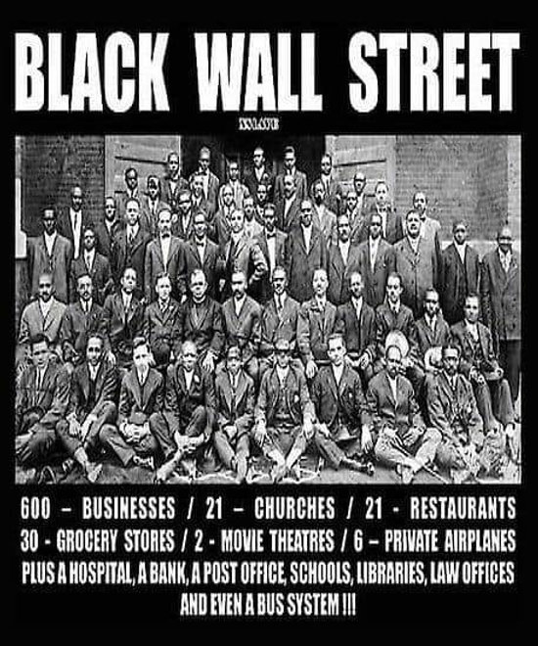
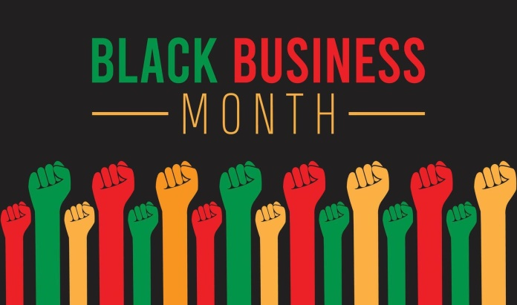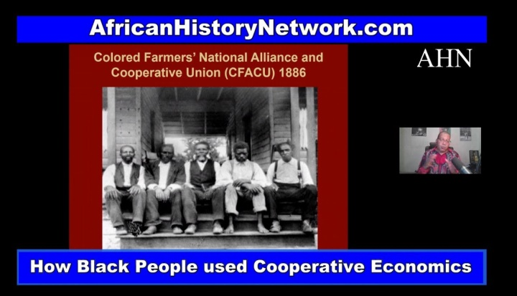

Mission Statement: To establish cooperative economic systems that promotes wealth creation, ownership, and shared prosperity among Kidnapped African-descended people.

Goals:
- Build and sustain Kidnapped African-owned enterprises and cooperatives.
- Develop youth entrepreneurship programs.
- Strengthen trade and investment networks with members of the Kidnapped Africans here in the United Snakes of America.
Statement of Purpose: To achieve economic sovereignty through unity, innovation, and collective ownership.

Officers:
Chairman – Oversees overall operations and strategic direction.
Vice Chairman – Coordinates implementation and assists with planning.
Secretary – Manages documentation, reporting, and internal communications.

Politics & Governance Department:
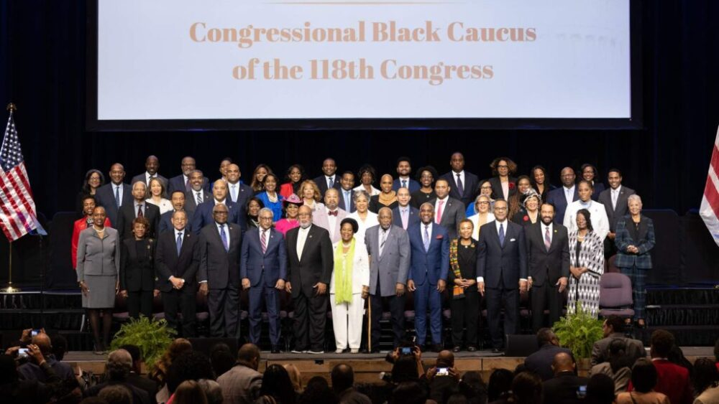
Mission Statement: To empower communities through political education, civic engagement, and the development of effective leadership structures.
Goals:
Increase voter education and political literacy.
Train community leaders and advocates.
Influence public policy that supports the Kidnapped African Communities.
Statement of Purpose: To ensure our people are active participants and decision-makers in the political systems that shape their lives.

Officers:
Chairman – Oversees overall operations and strategic direction.
Vice Chairman – Coordinates implementation and assists with planning.
Secretary – Manages documentation, reporting, and internal communications.

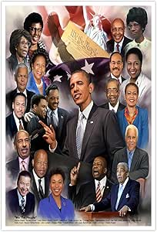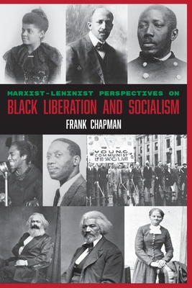

Health & Wellness Department:
Mission Statement: To restore the holistic health of our people—body, mind, and spirit—through education, access, and traditional African healing practices.
African healing and nutrition - Create wellness ambassador programs.
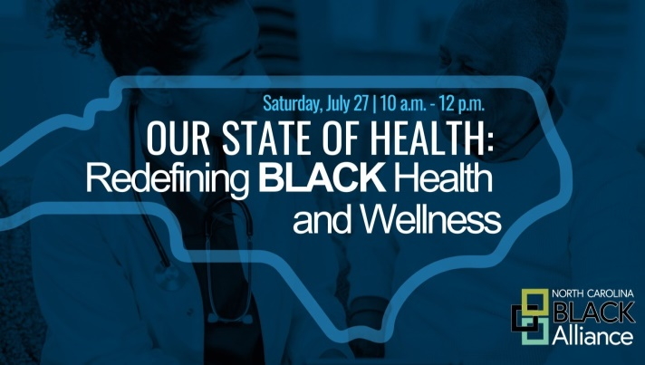
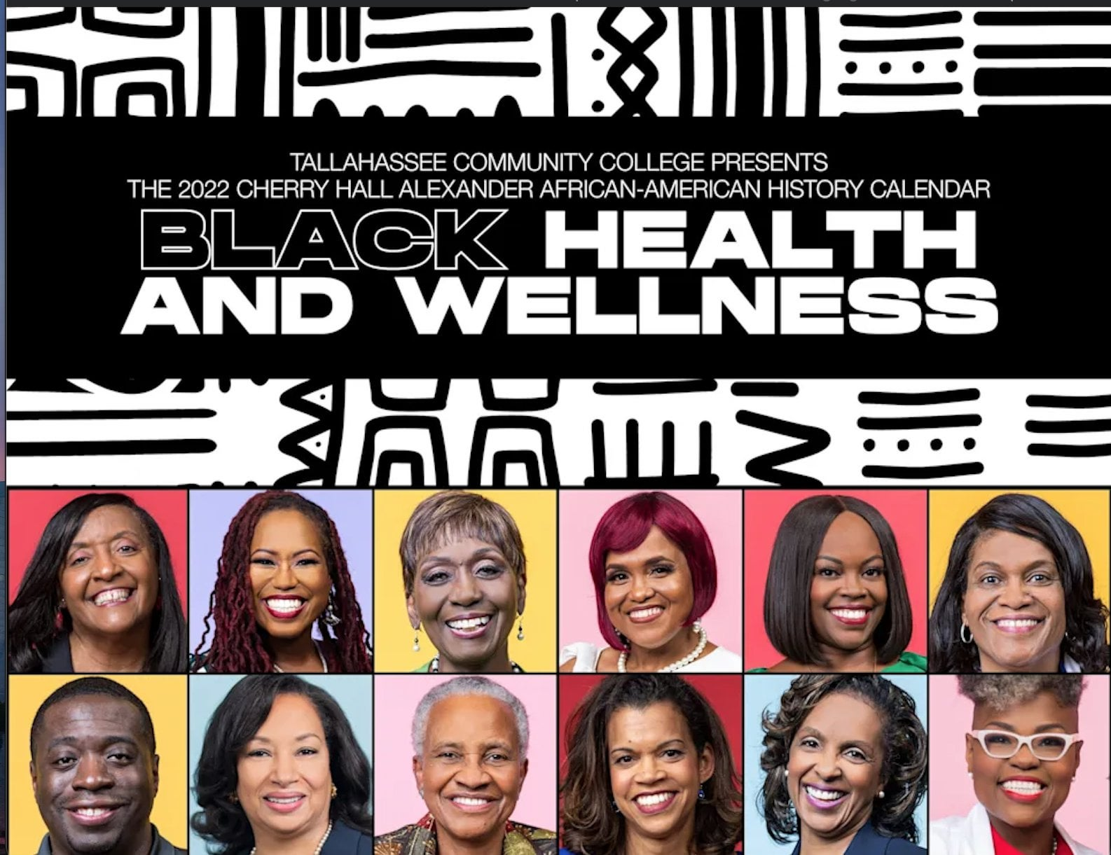

Goals:
- Establish community health and wellness centers.
- Promote physical fitness and nutrition programs.
- Support mental and spiritual health initiatives.
Statement of Purpose: To build communities of balance and vitality by merging traditional and modern wellness systems.

Officers:
Chairman – Oversees overall operations and strategic direction.
Vice Chairman – Coordinates implementation and assists with planning.
Secretary – Manages documentation, reporting, and internal communications.

Agriculture & Land Restoration Department
Mission Statement: To reclaim land and restore agricultural sovereignty through sustainable and Afrocentric practices.

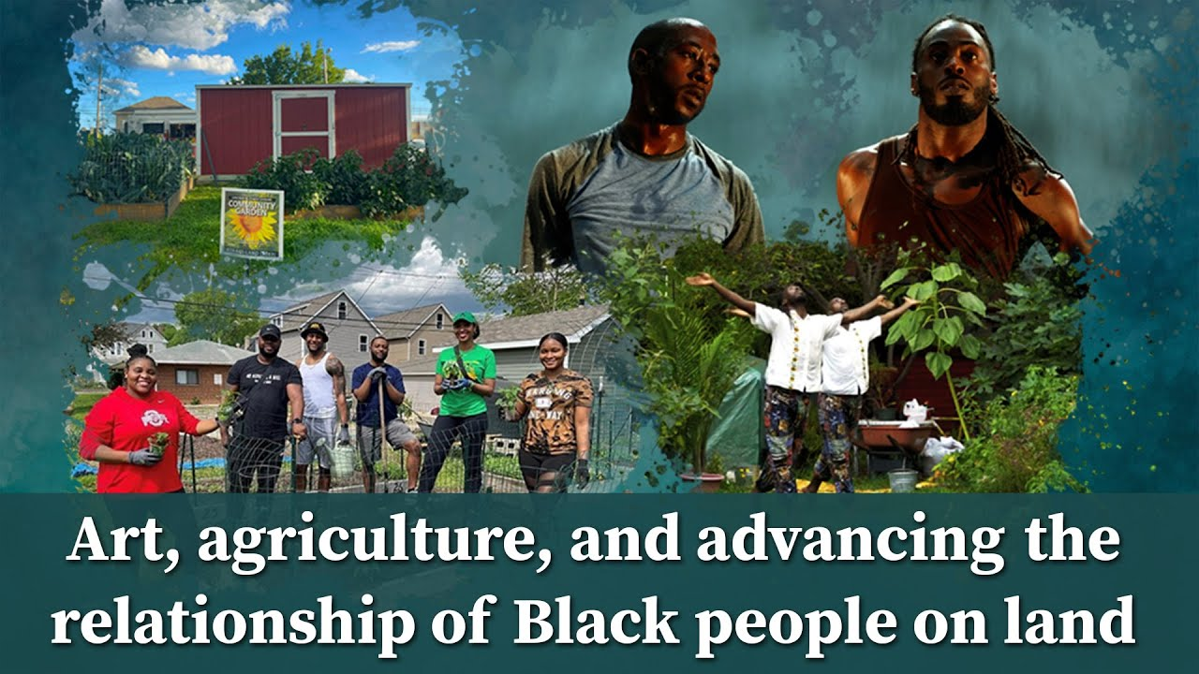 Goals:
- Acquire land for community use and farming.
- Train the next generation in agriculture and environmental stewardship.
- Establish food cooperatives and markets.
Statement of Purpose: To reconnect our people with the land as the foundation of independence, health, and heritage.

Officers:
Chairman – Oversees overall operations and strategic direction.
Vice Chairman – Coordinates implementation and assists with planning.
Secretary – Manages documentation, reporting, and internal communications.

Education & Knowledge Reclamation Department
Mission Statement: To rebuild African-centered education systems that restore cultural consciousness, critical thinking, and vocational competence.
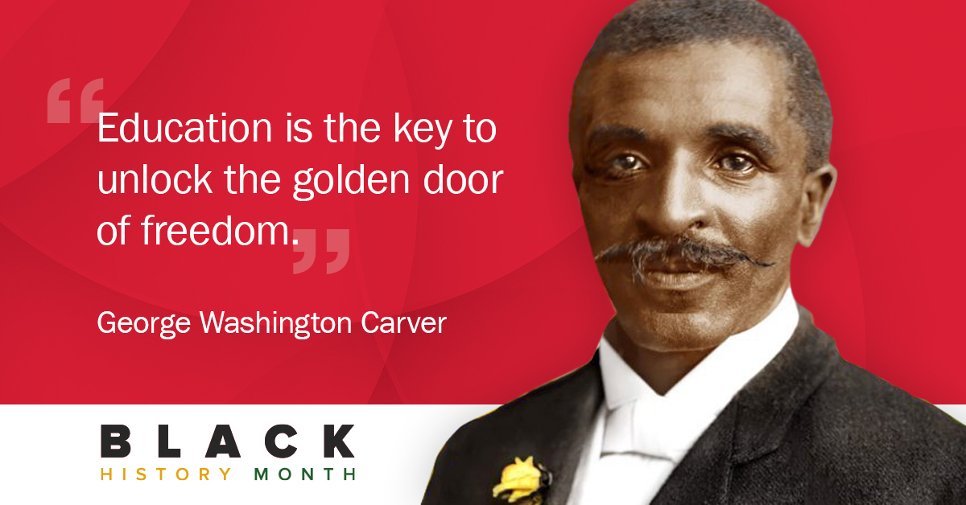
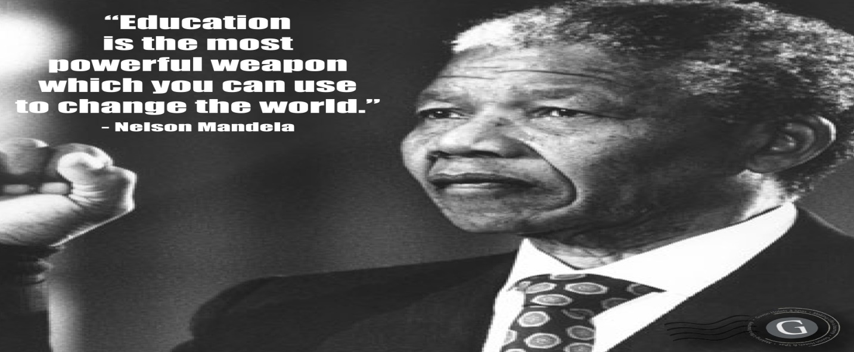

Goals:
- Establish independent schools and learning centers.
- Promote literacy, financial education, and cultural history.
- Train educators in Afrocentric pedagogy.
Statement of Purpose: To ensure education is a tool for liberation, not assimilation.

Officers:
Chairman – Oversees overall operations and strategic direction.
Vice Chairman – Coordinates implementation and assists with planning.
Secretary – Manages documentation, reporting, and internal communications.

Community Safety & Security Department
Mission Statement: To ensure the protection, peace, and safety of our communities through restorative justice, training, and community vigilance.
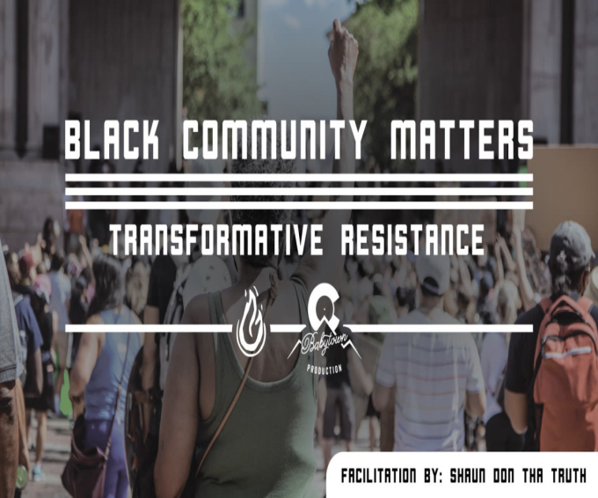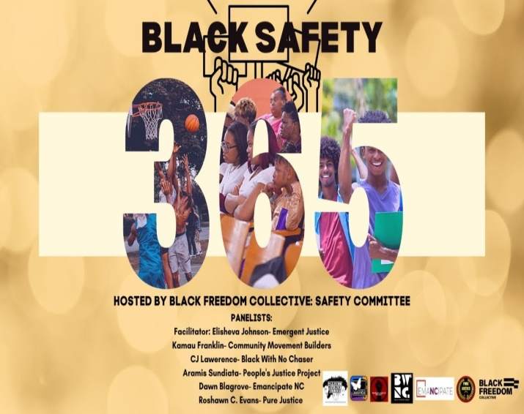
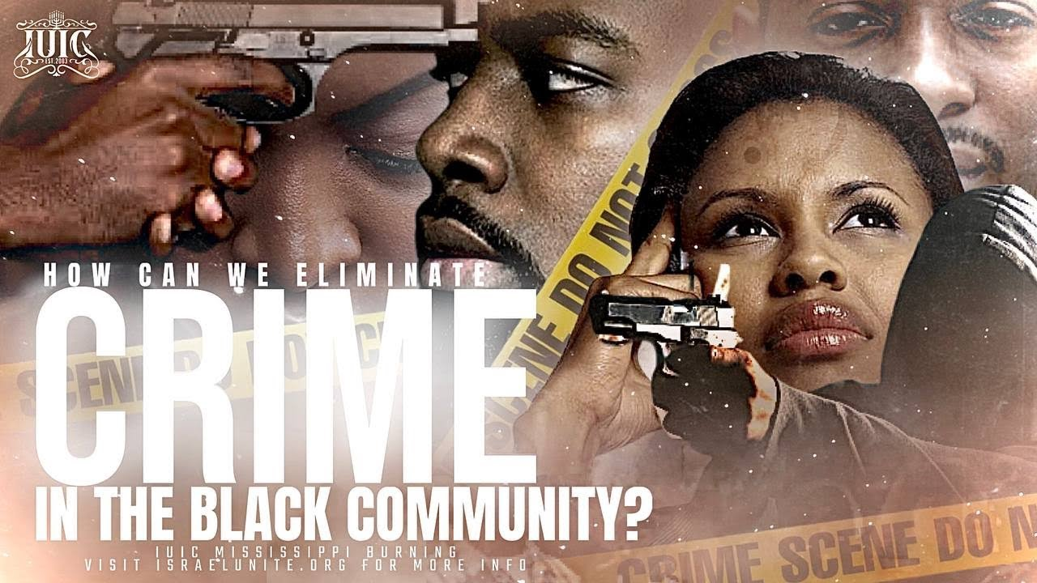

Goals:
- Create community peacekeeping systems.
- Develop restorative justice and conflict mediation networks.
- Build partnerships with legal and civic organizations.
Statement of Purpose: To reclaim control over community safety and protect our families and neighborhoods with dignity and discipline.

Officers:
Chairman – Oversees overall operations and strategic direction.
Vice Chairman – Coordinates implementation and assists with planning.
Secretary – Manages documentation, reporting, and internal communications

Communication & Media Outreach Department
Mission Statement: To build and control our own narrative through media ownership, cultural storytelling, and strategic communication.
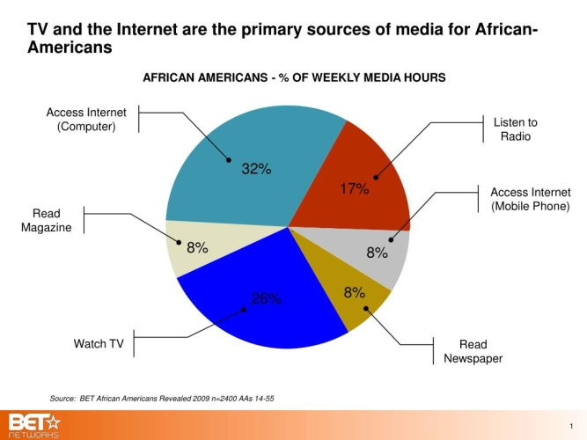

Goals:
- Create and manage community-based media outlets.
- Produce content that uplifts and educates.
- Develop global networks of African media producers.
Statement of Purpose: To reclaim our story, amplify our voices, and ensure our perspectives shape the global narrative of who we are as an ethnic group.

Officers:
Chairman – Oversees overall operations and strategic direction.
Vice Chairman – Coordinates implementation and assists with planning.
Secretary – Manages documentation, reporting, and internal communications.

Data & Statistics Department:
Mission Statement: To collect, analyze, and report data that guides evidence-based decision-making across all Sankofa Movement initiatives.


Goals:
- Establish systems for community data collection.
- Develop progress-tracking and evaluation tools.
- Maintain transparency and accountability in reporting.
Statement of Purpose: To ensure that our growth is measurable, strategic, and scientifically grounded.

Officers:
Chairman – Oversees overall operations and strategic direction.
Vice Chairman – Coordinates implementation and assists with planning.
Secretary – Manages documentation, reporting, and internal communications.

IV. Conclusion
The Sankofa Master Plan Movement is a living system—evolving through the participation and commitment of the Kidnapped Africans here in the United Snakes of America who understand the important of working together to save ourselves and our children yet to be born. Together, through these Departments and shared principles, we will restore what was lost, strengthen what remains, and build what is yet to come.

